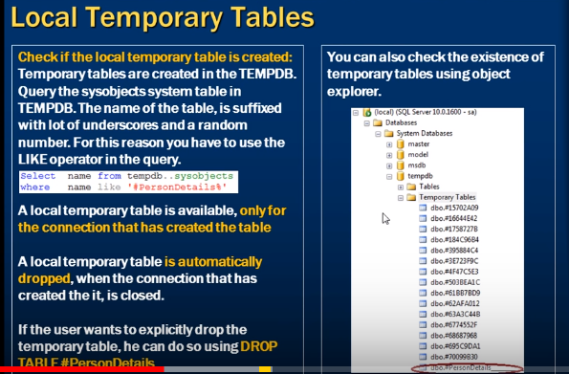

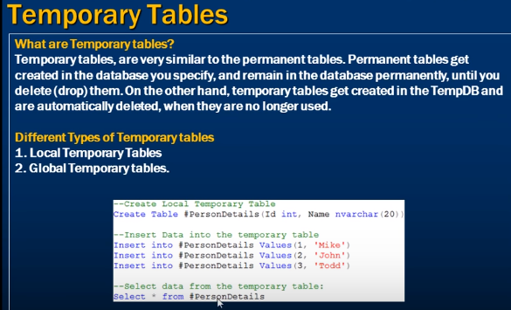

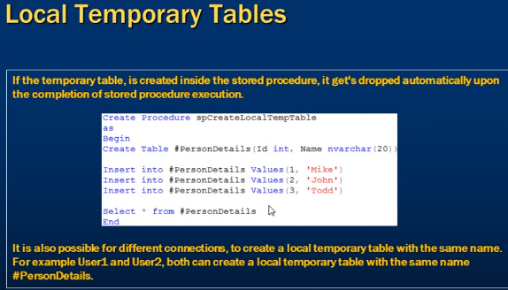

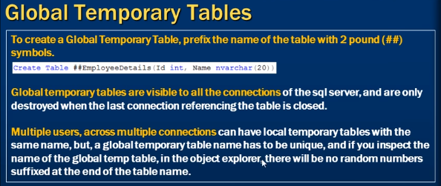

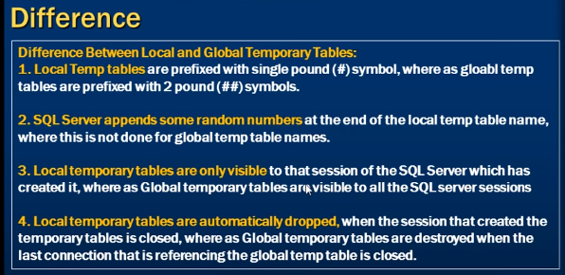

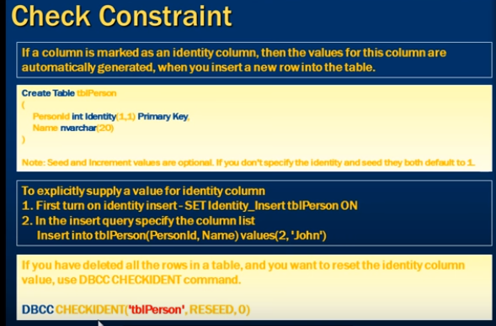



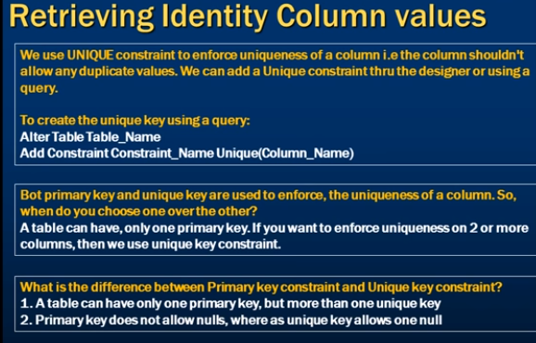

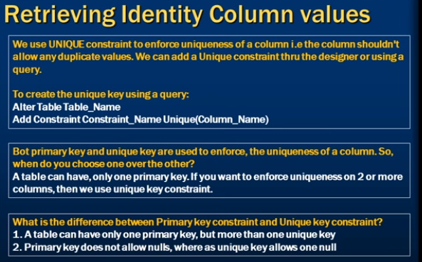

Primary key also enforce uniqueness of column but we cannot have more than one primary key.

Suppose we want email_id, passport_id , person_id all as unique, in this case we cannot apply primary key on all columns that’s why we need unique key.

A table can have more than one unique key

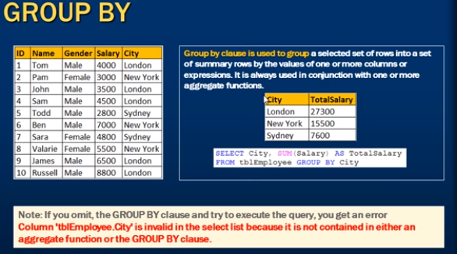

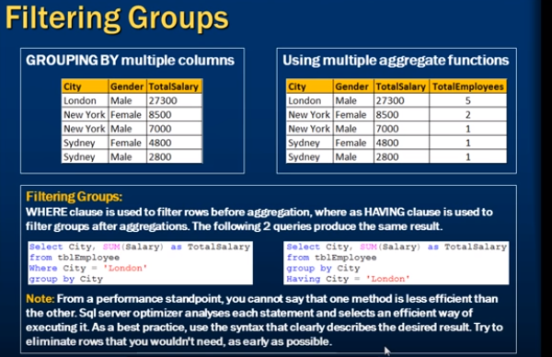

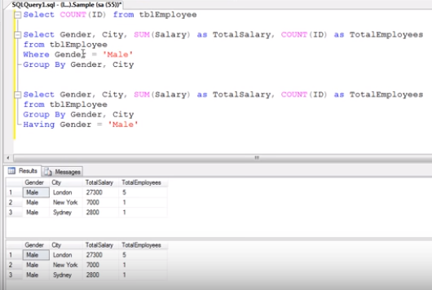

Aggregate will apply on only male for where clause

Whereas having filters group after aggregation is applied

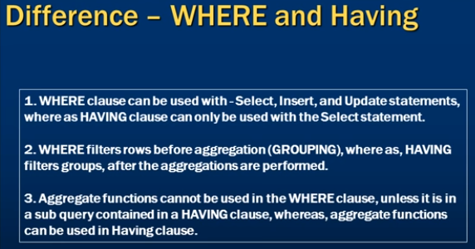

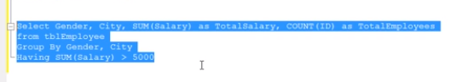

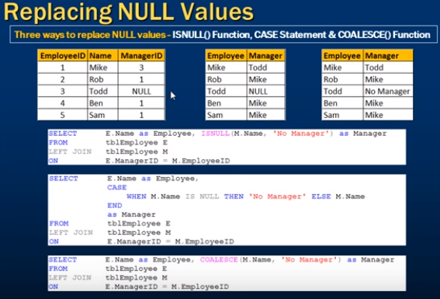

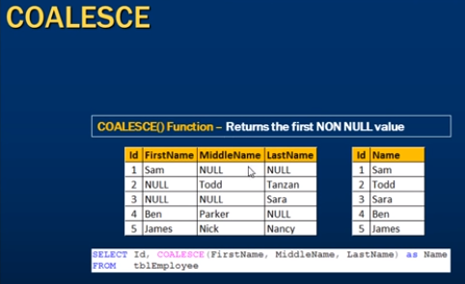

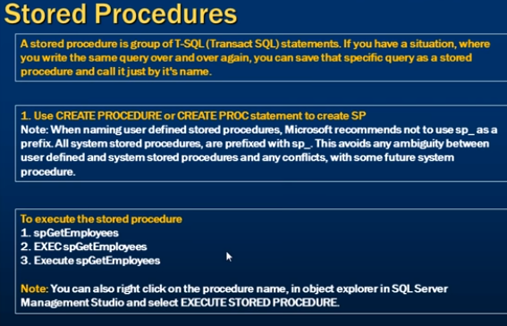

Order is important for parameter SP otherwise it will throw exception.

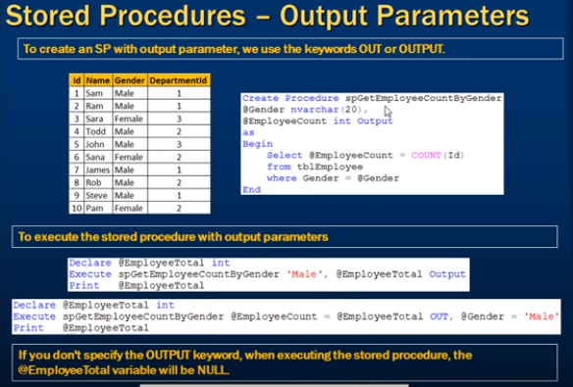

Output parameter will return something back to us.

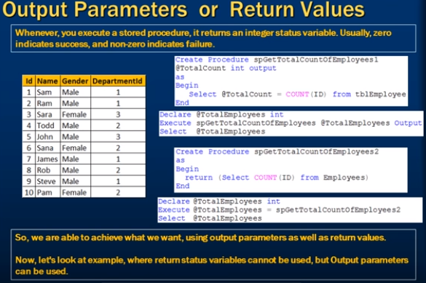

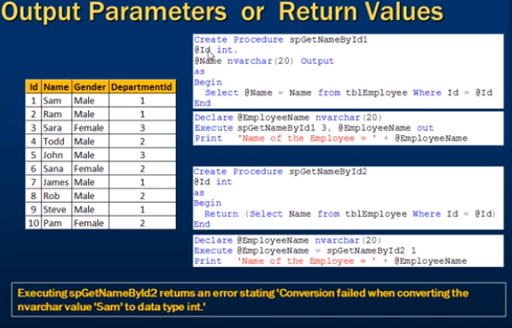

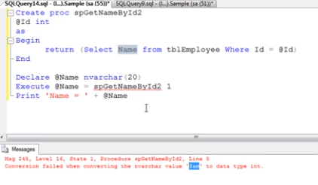

We use return value only to return integer value and that too only one value.



1. A simple change in the sql query will led to new execution plan.

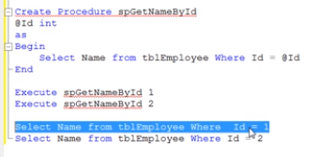

But that’s not the case with stored procedure, SP can reuse the execution plan.

1. Network traffic

When we execute SP we specify

Execute SP name + parameter (optional)

so it will reduce the network and if we are using any adhoc sql query which has more numbers of line then it will create traffic network

1. Several application can use SP.

Advantage - if there is bug in SP or we want to update the SP, we can do that at only one place.

1. Better security

E.g.: suppose we want to give access for IT dept. only, so if we will give access to the table user can see the data of other department also.

In this case we can create Stored Procedure and give access to that SP only,

We can achieve security using view also.



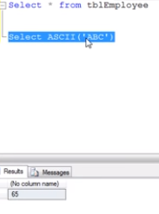It will give ascii code value for the first character

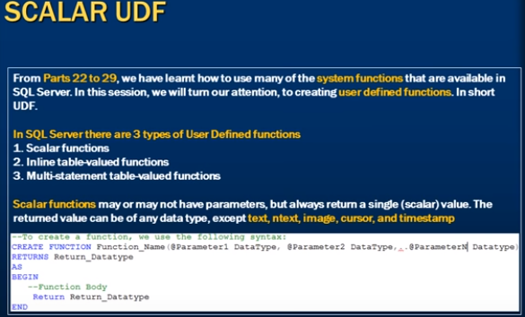

1. Function can have parameter or not but always return some value.

